**Setup Flowchart**

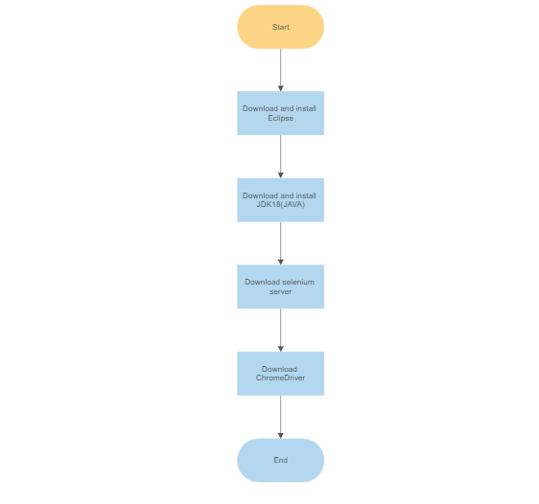

**Flowchart for Testing Proccess**

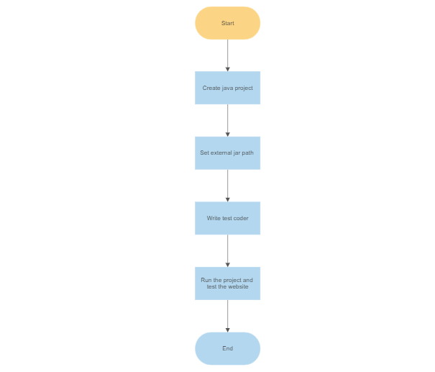

**Download Eclipse**

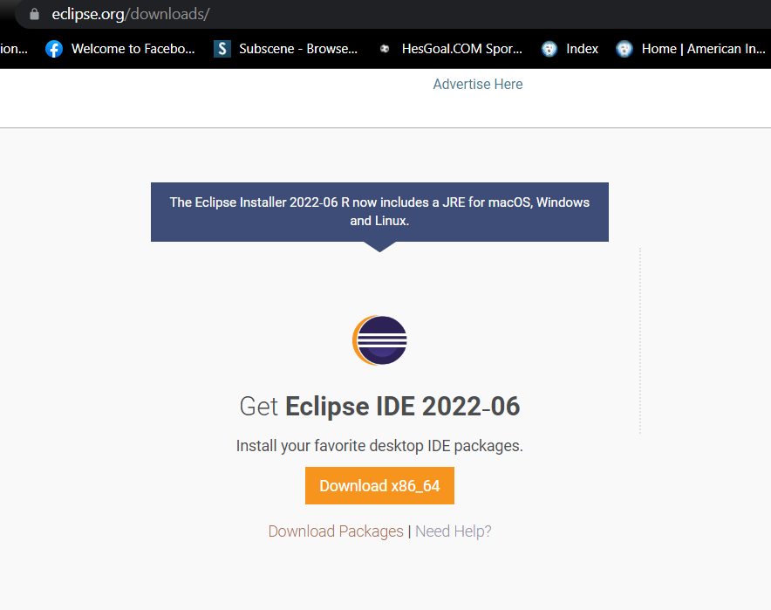

**Install Eclipse**

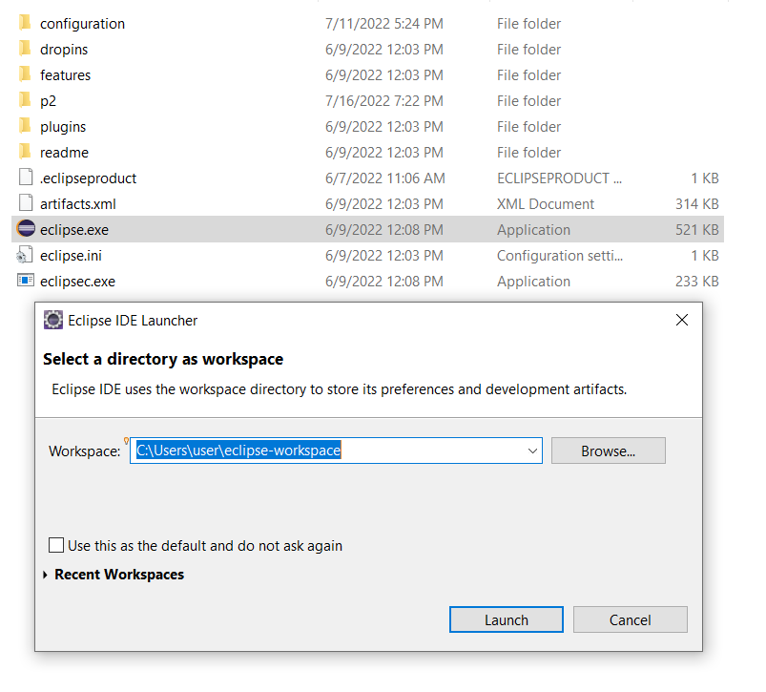

**Download Jdk 18(java)**

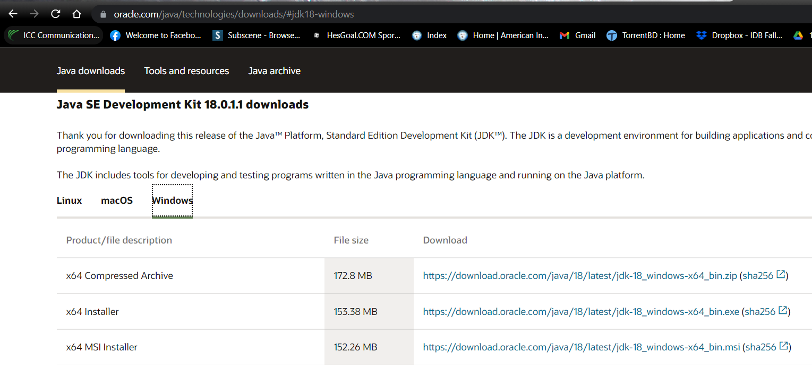

**Install java**

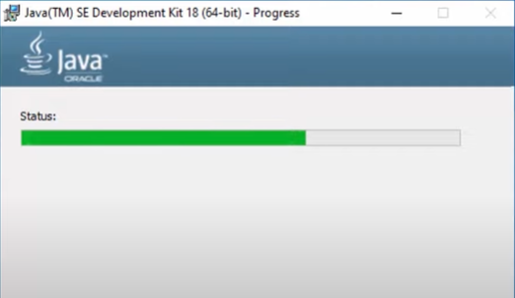

**Selenium Server Download**

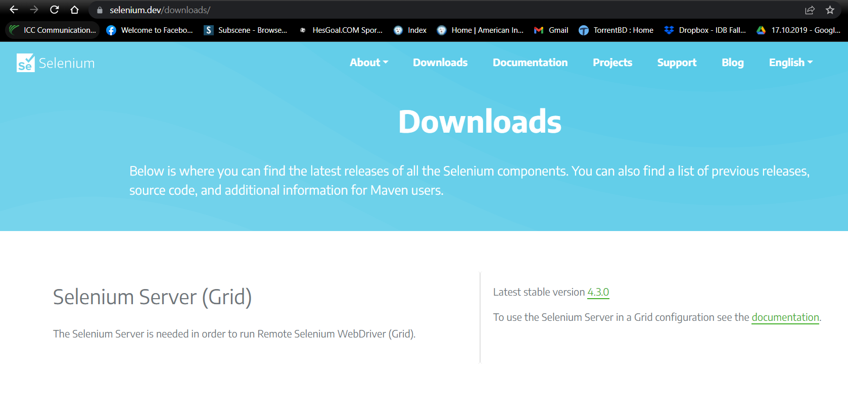

**Download ChromeDriver**

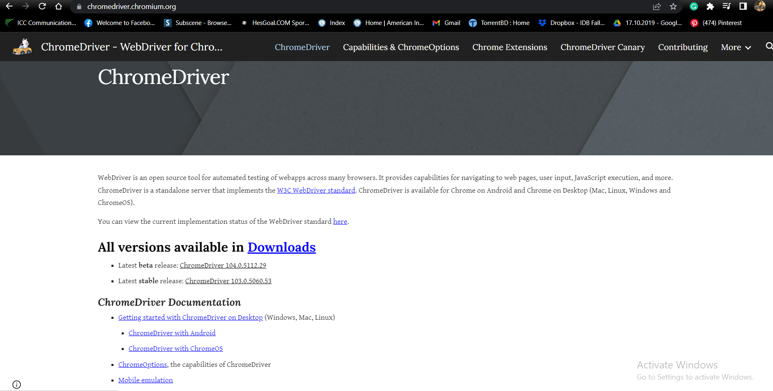

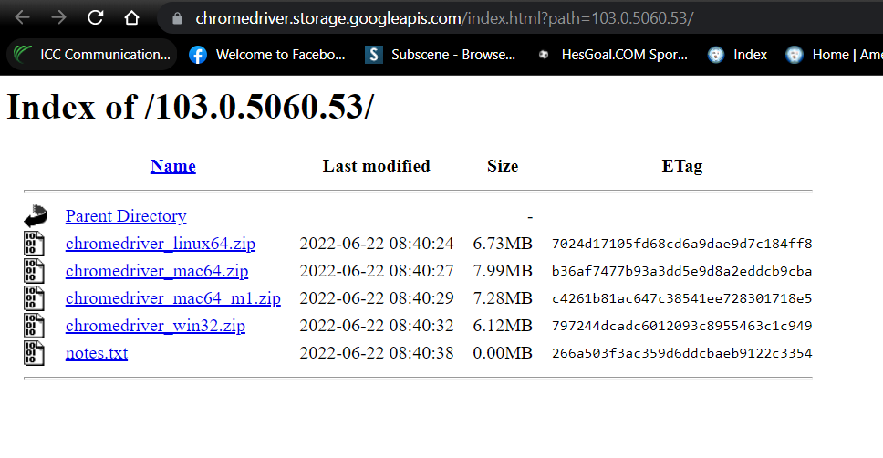

**Create new Java project in Eclipse**

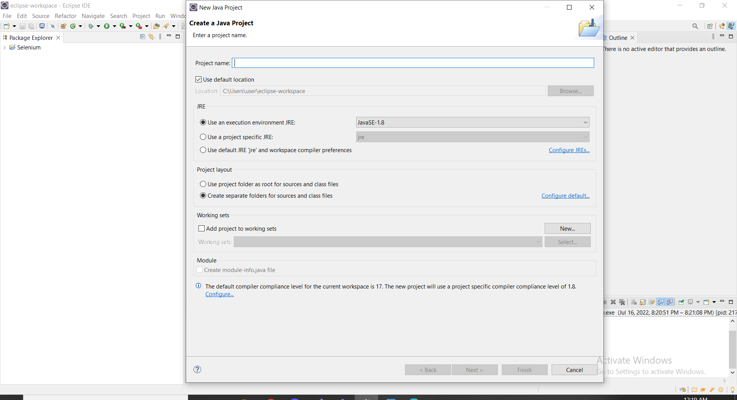

**Write testing code**

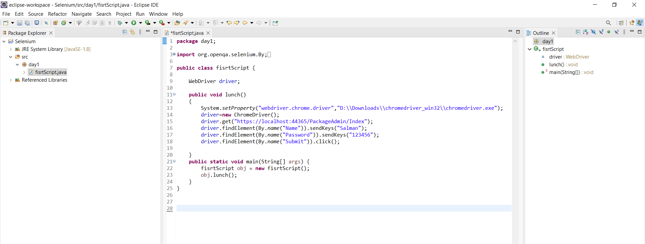

**Testing my Project**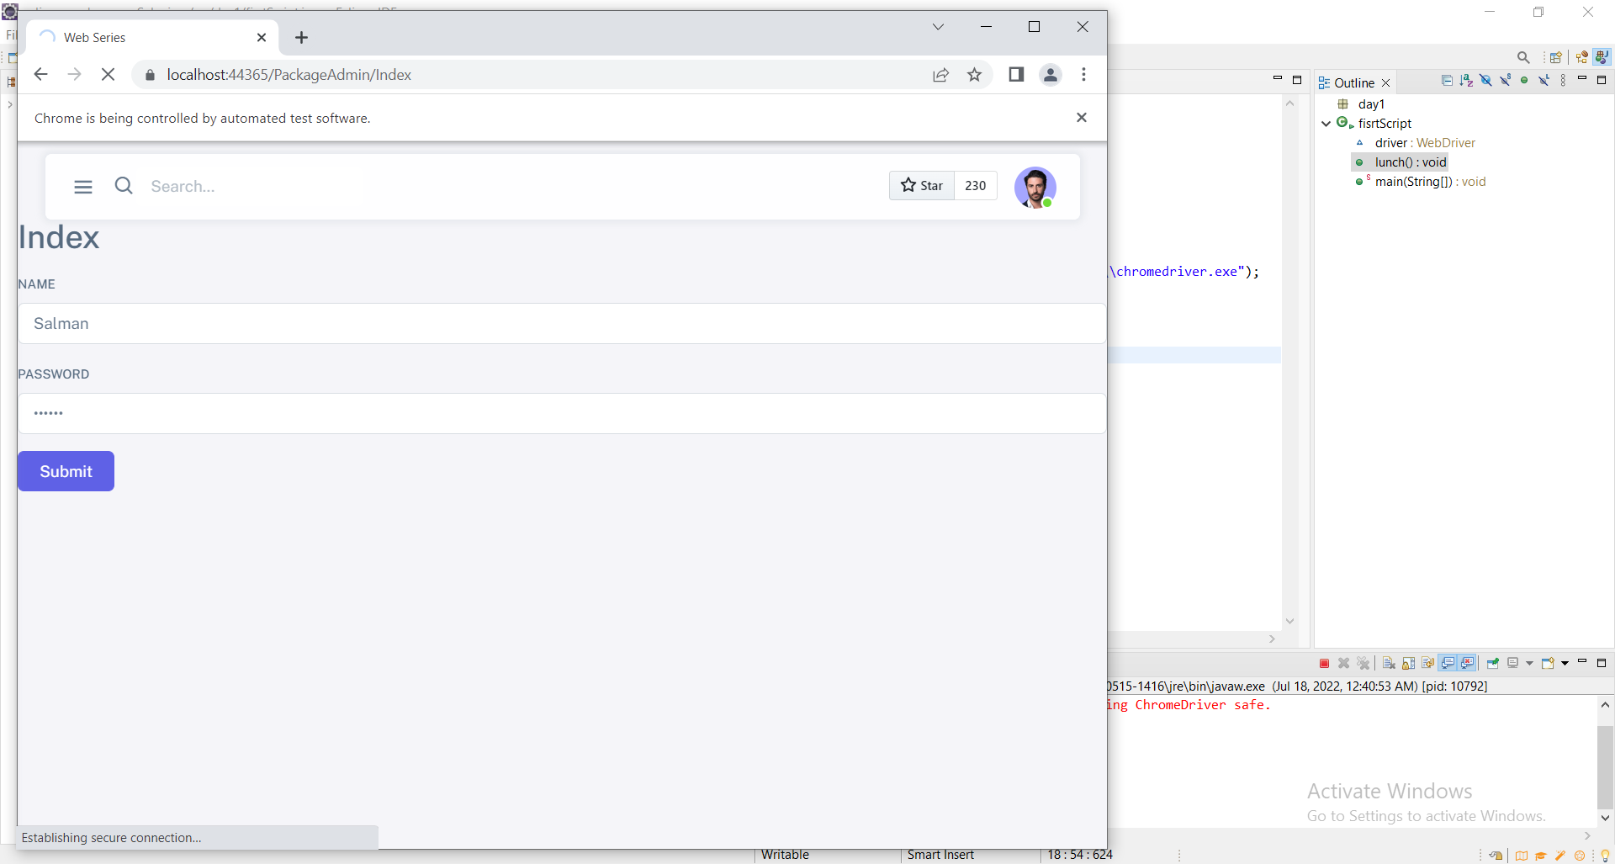

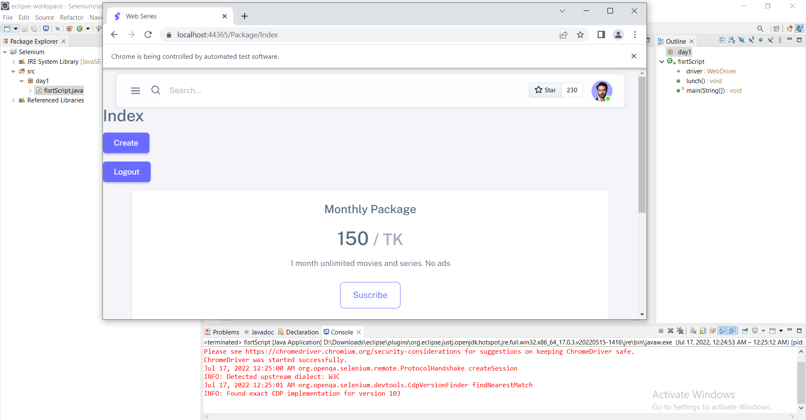

**Test Code :**

**package day1;**

**import org.openqa.selenium.By;**

**import org.openqa.selenium.WebDriver;**

**import org.openqa.selenium.chrome.ChromeDriver;**

**public class fisrtScript {**

**WebDriver driver;**

**public void lunch()**

**{**

**System.setProperty("webdriver.chrome.driver","D:\\Downloads\\chromedriver_win32\\chromedriver.exe");**

**driver=new ChromeDriver();**

**driver.get("https://localhost:44365/PackageAdmin/Index");**

**driver.findElement(By.name("Name")).sendKeys("Salman");**

**driver.findElement(By.name("Password")).sendKeys("123456");**

**driver.findElement(By.name("Submit")).click();**

**}**

**public static void main(String[] args) {**

**fisrtScript obj = new fisrtScript();**

**obj.lunch();**

**}**

**}**